**BCVD1007 – Full Stack Development II – Lab 6**

* Events

**Developer Note:**

* Use the web documents and window web api

References:

<https://developer.mozilla.org/en-US/docs/Web/API/Document>

**Exercise 1:**

Create a html document named **Ex1.html** and code the following functionality.

* Add mouse event functionality to the both of buttons to will trigger functions to AddElements and RemoveElements
* Add Element will add a child paragraph element to the container element
  + Add the text ‘this is a paragraph’
  + Add the class provided to each paragraph element
* Remove Element will remove a child element from the container element
  + Add a check so that no errors are throw trying to remove children, if there is no child elements

Use the starter code found here:  
<https://tinyurl.com/y3rjqa4f>

This is the starter interface  
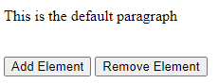

The expected output should be as follow  
:*(Paragraph elements are dynamic, based on number of Add Child clicks)*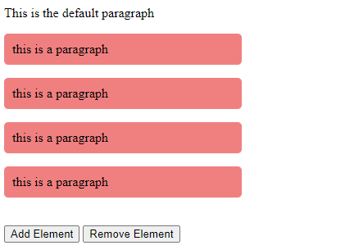

**Exercise 2:**

Following the tutorial below on DOM Manipulation and Events to create a simple color game.

The tutorial can be found at the following link: <https://tinyurl.com/yxvjxu8g>

